**CONTENTS**

1. **PART I:**

**SUBMISSION OF APPLICATION BY COMPUTER OPERATOR**

1. **PART II:**

**TRACKING OF APPLICATION STATUS BY COMPUTER OPERATOR**

1. **PART III:**

**ISSUANCE OF CERTIFICATE BY PRADHAN GRAM PANCHAYAT**

1. **PART IV:**

**REPORTING AND CERTIFICATE DISPATCH BY PRADHAN GRAM PANCHAYAT**

**FLOWCHART**

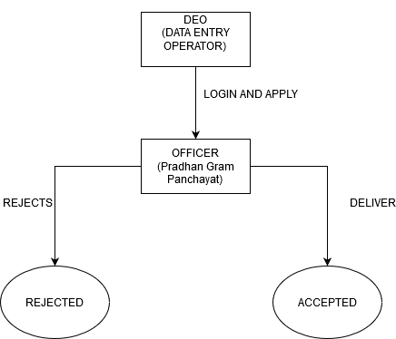

**PART I:**

**SUBMISSION OF APPLICATION: (BY COMPUTER OPERATOR)**

STEP 1:

**At first login to Service plus web portal: (** [http://tathyasathi.bangla.gov.in](http://tathyasathi.bangla.gov.in/configure/login.do?))

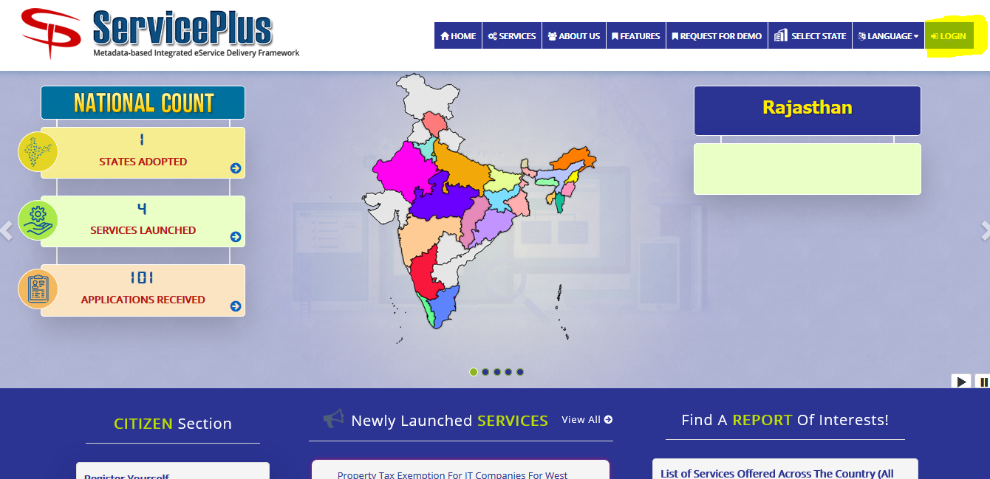

STEP 2:

Login as highlighted with the required credentials such as User ID and Password as shown below with the captcha.

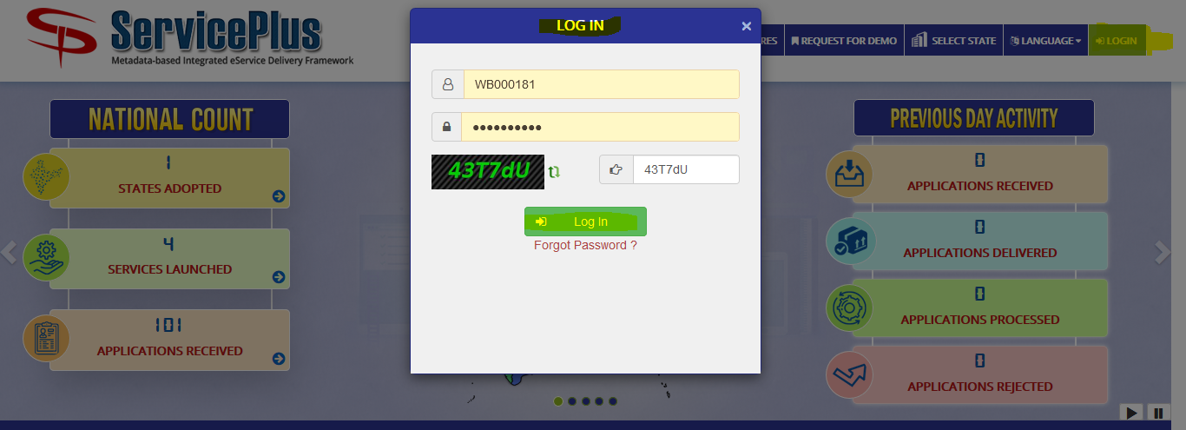

STEP 3:

After Logging In select “**Apply for Services**” from the dashboard and select “**View all available services**” to view your submitted service.

After selecting “**View all available services**” now select your **“Application for Issuance of Electricity Permission Certificate - GP”** to check your application.

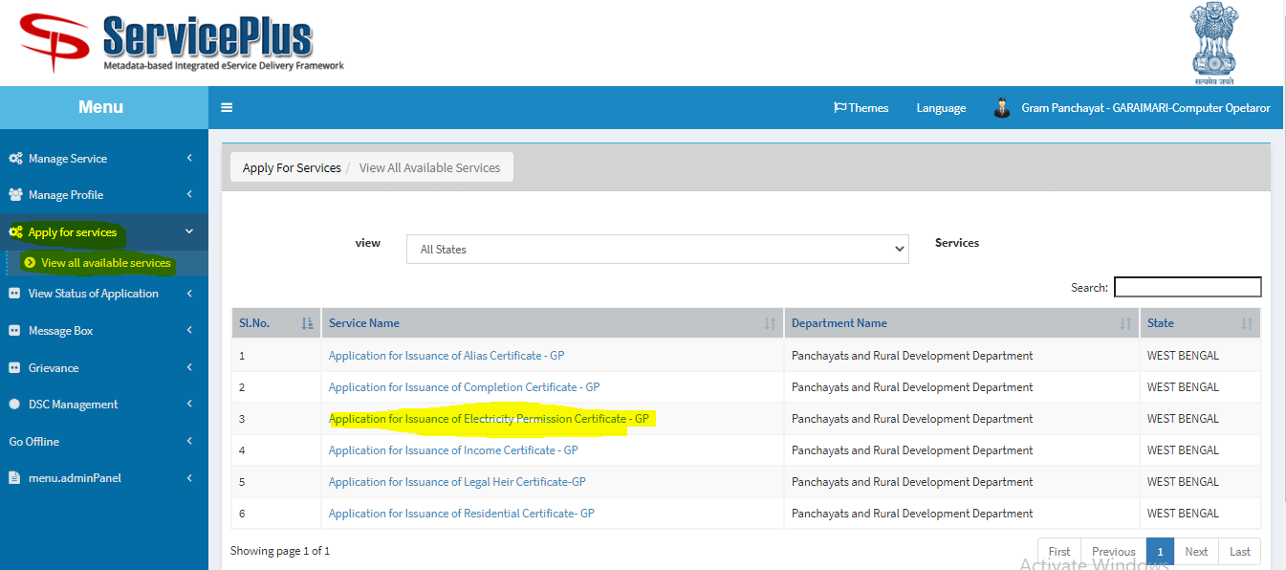

STEP 4:

Now fill in with the valid applicant’s details as required.

After filing the details, give the required captcha and submit the form.

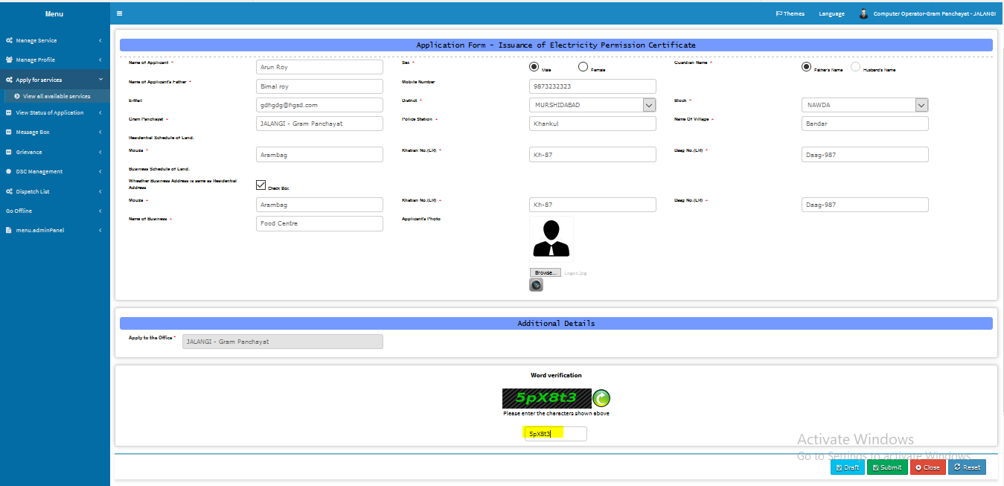

STEP 5:

This is preview after which you can re edit it or submit it.

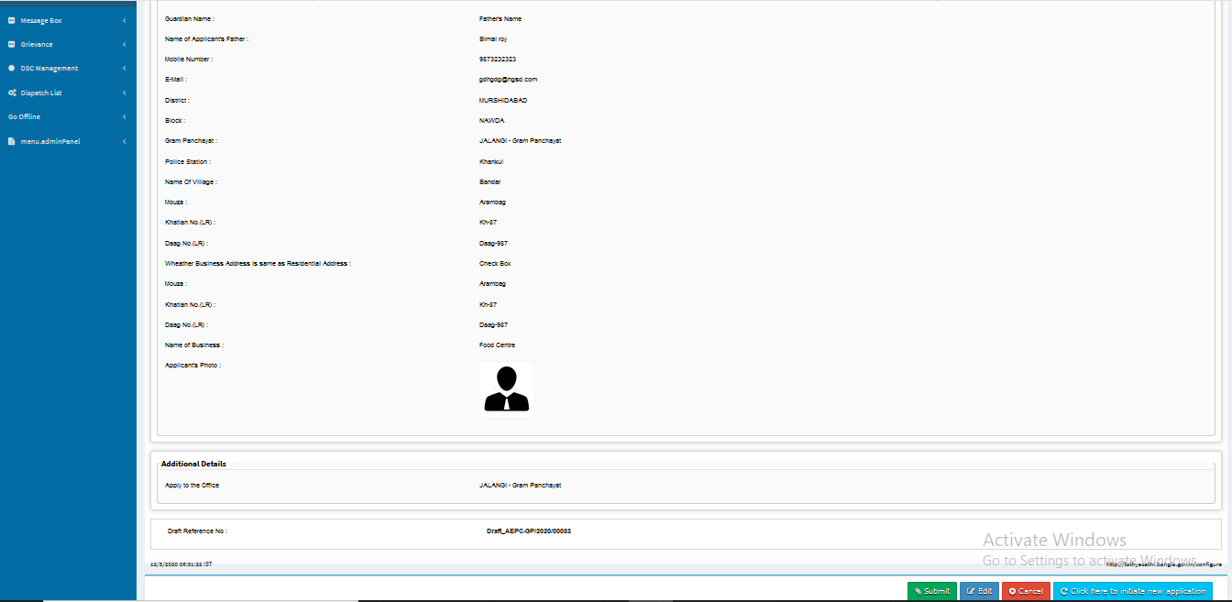

STEP 6:

This is the applicant’s acknowledgement slip with App ref-no which can be printed or downloaded as pdf.

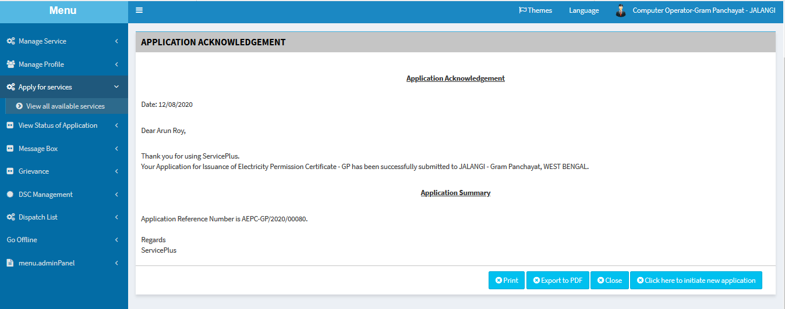

**PART II:**

**TRACKING FOR ISSUANCE OF APPLICATION CERTIFICATE: (BY COMPUTER OPERATOR)**

STEP 1:

The Applicant’s application can be tracked by going to “**View Status of Application**” and selecting “**Track application status**” by providing application ref. no: ********** and selecting “**Get Data**” button.

After getting the lists of data select the preferable Service Name which is delivered.

BY selecting delivered we can get the details of the certificate.

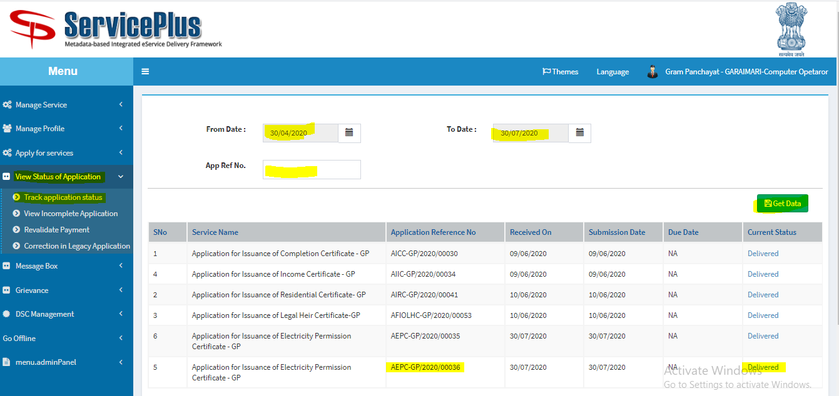

STEP 2:

After selecting delivered a modal pops up with applicant’s all details such as their certificate provided, application submission form etc. which can be downloaded for future use.

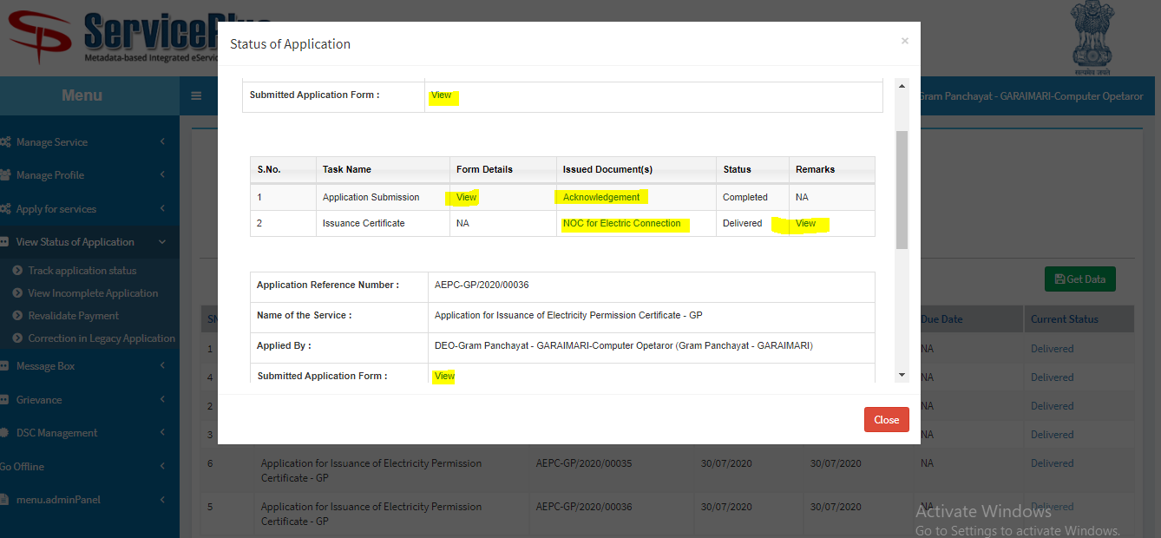

STEP 3:

This is the demo Certificate.

The QR code and ref: no. is unique.

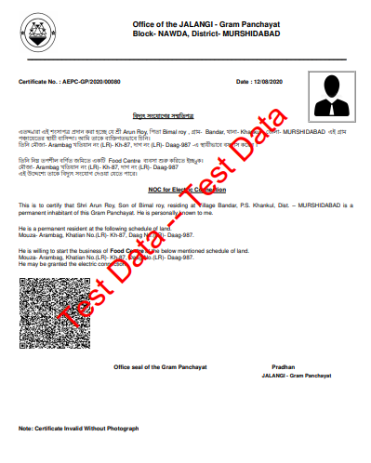

**PART III:**

**ISSUANCE OF CERTIFICATE: (BY PRADHAN GRAM PANCHAYAT)**

STEP 1:

**At first login to Service plus web portal: (**http://tathyasathi.bangla.gov.in)



STEP 2:

Login as highlighted with the required credentials such as User ID and Password as shown below with the captcha.

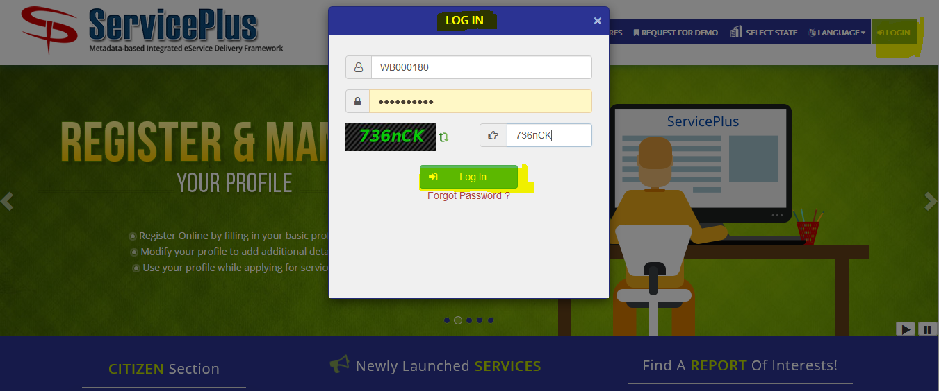

STEP 3:

Here the applicant’s application can be accepted or rejected by going to “**Message Box**” and selecting “**Inbox**”.

Here the Pradhan has to select service “**Application for Issuance of Electricity Permission Certificate - GP**” and fetch data by hitting the button **“Get Data**” which leads to the list of pending applications.

Here “**Application Number**” can be selected to get the applicant’s detail and “**Take Action/Pull**” would lead to a new page for issuing the certificate or rejecting it.

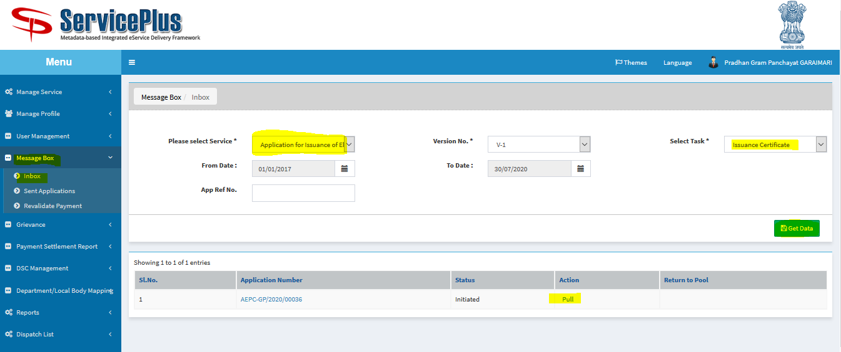

STEP 4:

At first see view history then,

By selecting Action of rejecting or delivering the certificate with the respective remark can lead to form rejection or approval.

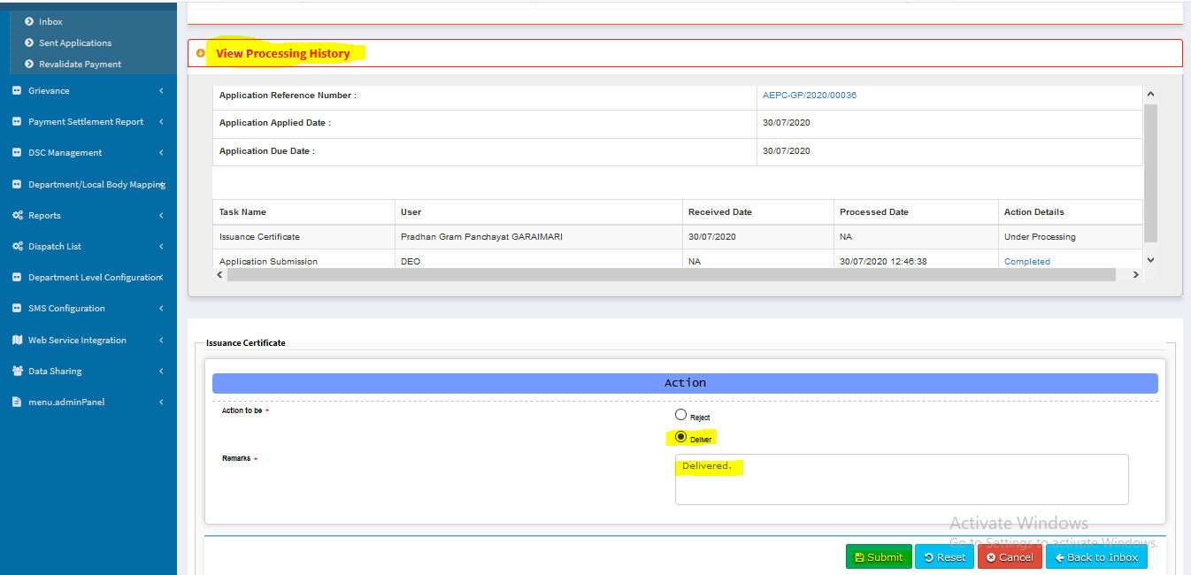

STEP 5:

Certificate can be shown by clicking the Document icon.

Select signed option then submit.

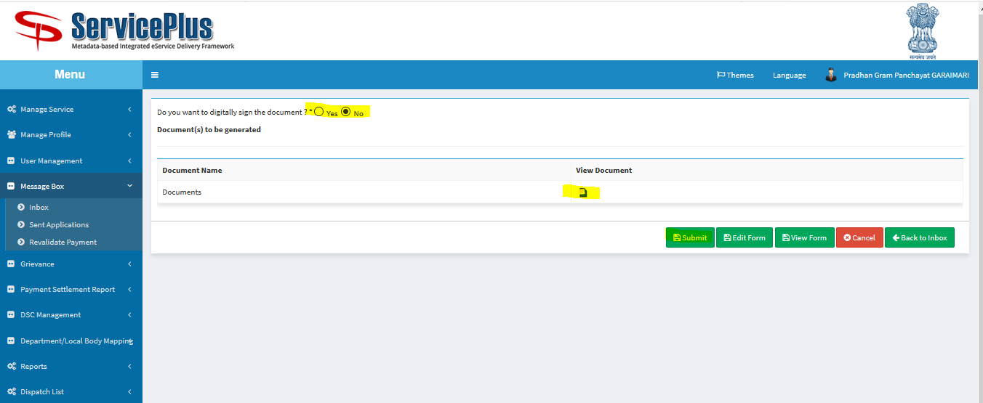

This is the demo certificate.



STEP 6:

Like this other application can be approved or rejected by the Pradhan authority.

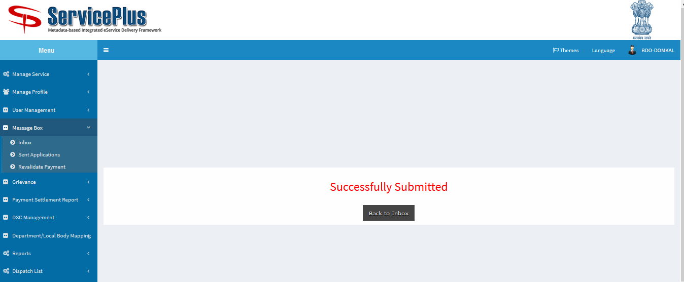

**PART IV:**

**Reporting And Certificate Dispatch: (BY PRADHAN GRAM PANCHAYAT)**

STEP 1:

Login as Pradhan Gram Panchayat and go to “**Dispatch List**” and select “**View Delivered Services**” which lead to open to get the data.

We can “**select the service**” and we can also get the data in respect of date from “**from date - to date**”.

There is a option to get the data in respect of particular “**App Ref No.**” too.

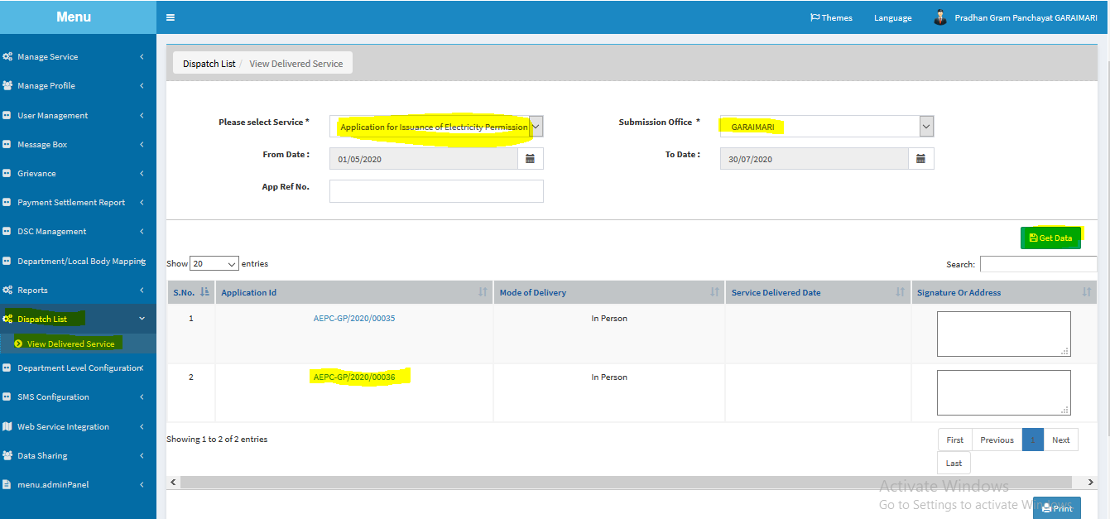

STEP 2:

Select the “**Application ID**” to get the dispatched certificate like below.

We can get a printout by the print button given there.

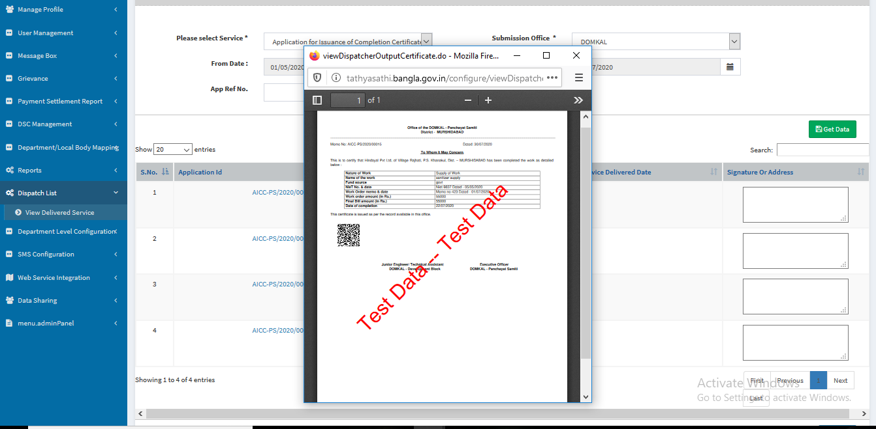

STEP 3:

Select to print from the list.

